GENIUS MONKEY
Rebrand content and SEO, executive summary
Keyword strategy, content clusters, and the internal and external linking model for the new site architecture.
June 28, 2026 Source: Ahrefs (US) and Google Search Console

1. The situation
Two facts shape the entire plan.
- Commercial SEO is greenfield. Genius Monkey ranks for about 35 organic keywords and roughly 345 visits a month, almost all of it brand or old blog posts. The pages that sell rank for nothing commercial. Search Console confirms it: 62 percent of current impressions are vanity (28 percent brand, 25 percent a deprecated platform called appnexus, 9 percent case-study collateral).
- This is a replatform, not a new site. Existing pages already rank (how it works at position 2.9, the dashboard at 2.3, pricing, and the FAQ page). The rebrand has to redirect old URLs to the new ones or it loses those positions.

2. The strategy in four moves
- Win the definitions first (AEO). The biggest, cheapest, most on-brand wins are the what-is terms that feed AI answers: what is a dsp (5,400 / KD14), what is ctv (3,000 / KD9), plus the new glossary, guides, FAQ, and comparison pages.
- Take the winnable commercial mid-tail. programmatic advertising agency (3,000 / KD1), retail media (2,300 / KD6), geofencing (KD3 to 4), legal and travel and home-services advertising (KD2 to 5), DOOH (KD7).
- Cluster toward the hard heads. programmatic advertising (KD30), native advertising (KD65), and cpm (KD48) are not won head-on. Each is the top of a cluster whose spokes earn the authority that lifts the head.
- Cash the striking-distance wins now. Search Console shows impression tracking (pos 8), mer vs roas (pos 10), and programmatic cpm trends (pos 6) already near page one. One rewrite plus an internal link lands these faster than any new page ranks. The measurement hub and the FAQ hub go first.

3. Keyword clusters and their pages
Sixteen clusters. Each has a hub (the page that owns the topic) and spokes (supporting pages that link back to it). Full per-page detail, including secondary keywords and the AEO question bank, is in the page plan.
Cluster | Hub page(s) | Key spokes | Primary target (volume / KD)
Programmatic fundamentals | /platform, guides/what-is-programmatic-advertising | how-it-works, blog Fundamentals, glossary RTB | programmatic advertising (7,900 / KD30)
DSP | /platform, /glossary/dsp | comparisons/best-dsp, by-business/agency, glossary SSP | what is a dsp (5,400 / KD14)
CTV, OTT, video | /solutions/by-channel/ott-ctv, /video | glossary CTV and OTT, blog CTV, guide what-is-ctv | ctv advertising (2,100 / KD17)
Native | /solutions/by-channel/native | blog native examples, comparisons/native-vs-display | native advertising (7,900 / KD65)
Display | /solutions/by-channel/display | glossary, comparisons | programmatic display advertising (900 / KD28)
DOOH (new page) | /solutions/by-channel/dooh | blog, glossary DOOH | dooh advertising (1,100 / KD7)
Audio | /solutions/by-channel/audio | blog | programmatic audio advertising (450 / KD4)
Targeting, data, privacy | /platform/behavioral-targeting, /device-agnostic-targeting | blog Privacy, glossary (addressable, contextual, first-party) | behavioral targeting (1,200 / KD9); geofencing marketing (1,800 / KD4)
Attribution and measurement | /platform/measurement-validation | blog Attribution, glossary (roas, cpm, mer) | marketing attribution (2,100 / KD33); GSC quick wins
Ad fraud and brand safety | blog Ad Fraud, /platform/human-oversight | glossary (ad fraud, brand safety) | ad fraud (450 / KD12); brand safety (600 / KD17)
Industries (10 micro-clusters) | /industries/legal, /retail, /automotive, and 7 more | case studies plus the channels each vertical uses | legal (1,200 / KD5); retail (700 / KD0)
Solutions by business | /solutions/by-business/agency, /business, /enterprise, /ecommerce | platform, case studies | programmatic advertising agency (3,000 / KD1)
Comparisons and alternatives | /resources/comparisons | best-dsp, trade-desk-alternative, native-vs-display | best dsp (300 / KD0)
Glossary and definitions | /glossary | every definition entry (feeds all FAQs) | programmatic advertising glossary (150 / KD1)
AI in advertising | blog Industry Trends, /platform/real-time-optimization | blog posts | ai in advertising (1,700 / KD58); ai ad targeting (200 / KD0)
Seasonal and holiday | blog Seasonal | holiday posts, /industries/retail-ecommerce | holiday marketing (700 / KD5)

4. How the linking works
The diagram shows one representative slice of the model. Solid lines are internal links (hub to spoke and cross-cluster), dashed lines are glossary definition links, the dotted line is the call to action, and the hollow arrow is an outbound external citation.
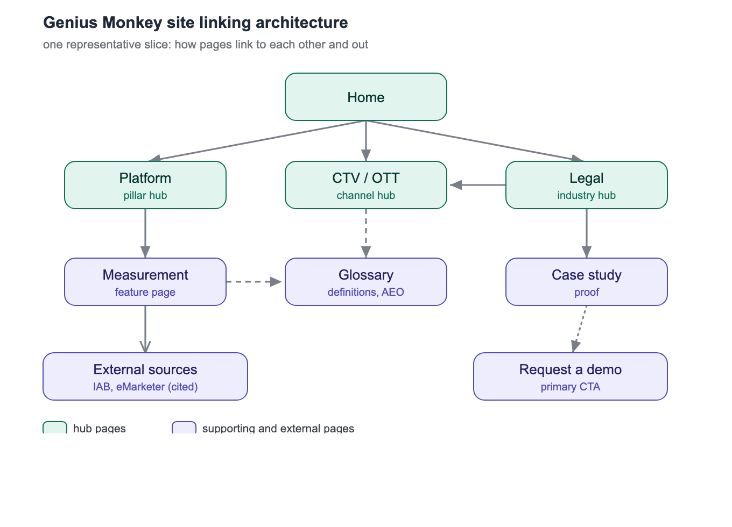

5. Internal linking
Six tiers. The goal is no orphan pages, with authority flowing from home down to the hubs and across to the pages that convert.
- Home to hubs. Home links to the eight pillars and the primary call to action, so every pillar sits one click from home.
- Hub to spoke, both ways. Each pillar links down to all its children, and each child links back up to its hub.
- Cross-cluster contextual links (the value layer). Each industry links to the two or three channels it uses, and channels link back. Platform features link into the channels that use them. Comparisons link to the pages they compare plus convert. Blog posts link up to their pillar or guide. Case studies link to their industry and channels.
- Glossary as connective tissue. Any jargon on any page links to its glossary entry, and each glossary entry links up to the pillar that sells that capability.
- One call to action per page. Every page carries a single contextual link to Request a Demo. Comparisons and high-intent pages link harder.
- Breadcrumbs. BreadcrumbList schema mirrors the hierarchy and doubles as internal linking and an AI-search signal.
Anchor text: link up to a hub using the spoke's target keyword as the anchor, varied naturally and always within brand voice. Never use a banned word as an anchor; write cross-channel, not omnichannel.
Redirect map: internal linking starts with not losing what exists. Every old URL with impressions gets a 301 to its new home (our-platform to /platform, how-it-works to /platform/how-it-works, faqs to /resources/faq, verticals to /industries, and so on). The full table is in the GSC insights file.

6. External linking
- Outbound citations (E-E-A-T and AEO). Every pillar and guide cites one to three authoritative sources for any statistic or claim (IAB, eMarketer, Nielsen, Think with Google, DoubleVerify). The architecture requires statistics with cited sources; this is how a page earns the citation and the AI-answer inclusion.
- Off-site entity presence (where Genius Monkey is cited from). An accurate Organization entity on Wikipedia or Wikidata, plus G2, Capterra, TrustRadius, LinkedIn, authentic Reddit and Quora participation, and YouTube. Brands are cited about 6.5 times more by AI when third parties corroborate them. Treat this as part of the build.

7. Build sequence
- Wave 1, quick wins. Glossary (DSP, CTV, RTB, SSP, CPM, ROAS), the measurement hub, the FAQ hub, comparisons (best dsp KD0), by-business/agency (KD1), the OTT/CTV, video, audio, and DOOH channel pages, /platform and the dashboard, the retail, legal, travel, home-services, and finance industry pages, and the DSP, CTV, and retail-media guides.
- Wave 2, core targets. Display and native channels, how it works, the remaining platform feature pages, the rest of by-business, the harder industries, the case-studies hub, about, pricing, request a demo, and the blog clusters.
- Wave 3. Enterprise, nonprofit, careers, partners, press, whitepapers, and spec sheets.

8. Risks and open decisions
- The redirect map is mandatory. A replatform without 301s drops the pages currently at position 2 to 3. This is the single biggest launch risk.
- DOOH is missing from the sitemap. It is a low-difficulty cluster worth a page. Decision: add the DOOH channel page, or fold it into display.
- Omnichannel and solutions are real keywords the brand bans. Recommendation: use the literal term only in a title tag, meta description, or schema for capture, and keep body copy on-brand. Confirm or veto.
- No real Genius Monkey stats yet. The plan and the voice both need actual numbers and the client roster for proof sections. Search volumes are demand, never to be used as company stats.
- Sitemap shows 590 submitted, 0 indexed. Likely a reporting quirk, but verify index coverage before and after launch.

9. Next step
Pick a Wave 1 page and we draft it through the gm-content skill (the measurement hub or the glossary is the strongest start), or expand the redirect map into a full launch checklist. The keyword target, secondaries, AEO questions, internal links, and schema for every page are already specified in the page plan.

